**Check Balance :**

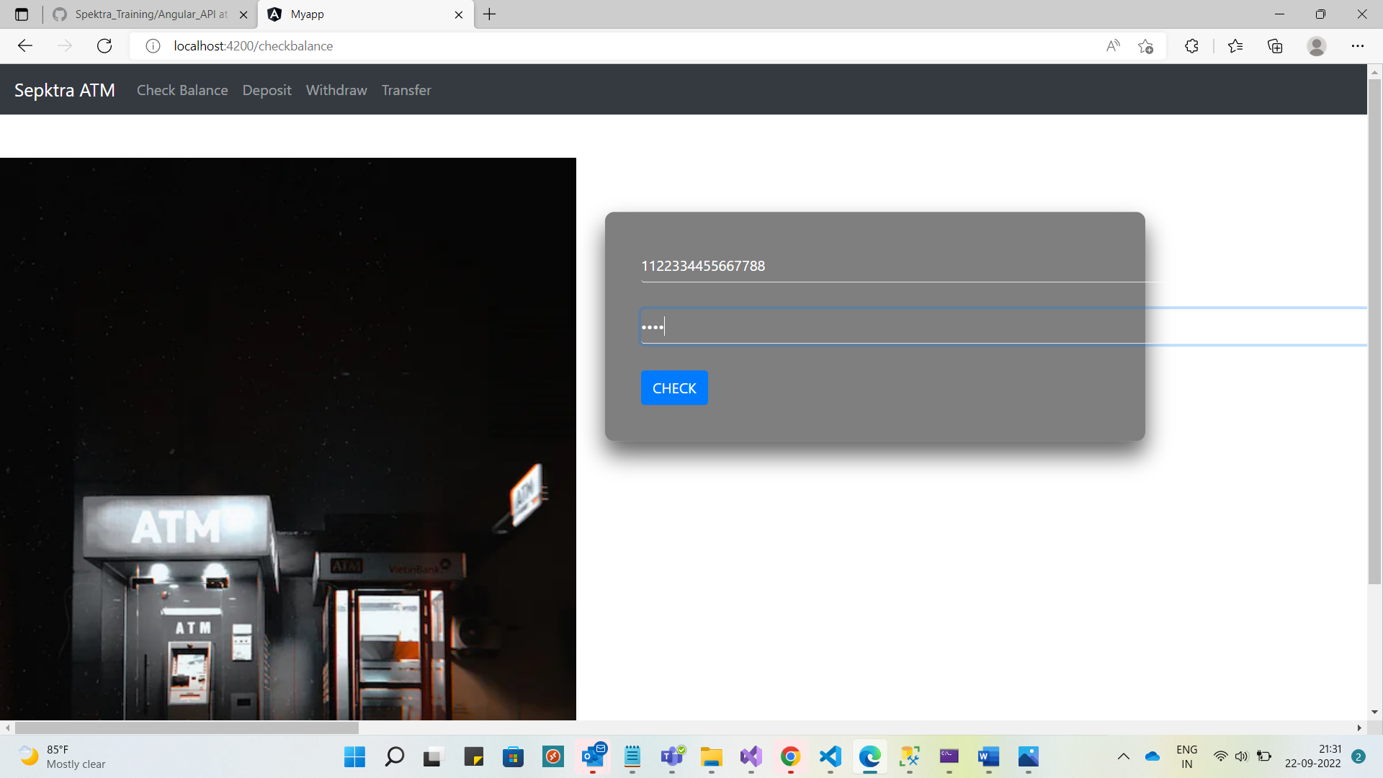 **Checked :**

**withdraw :**

**Credentials. Withdrawed**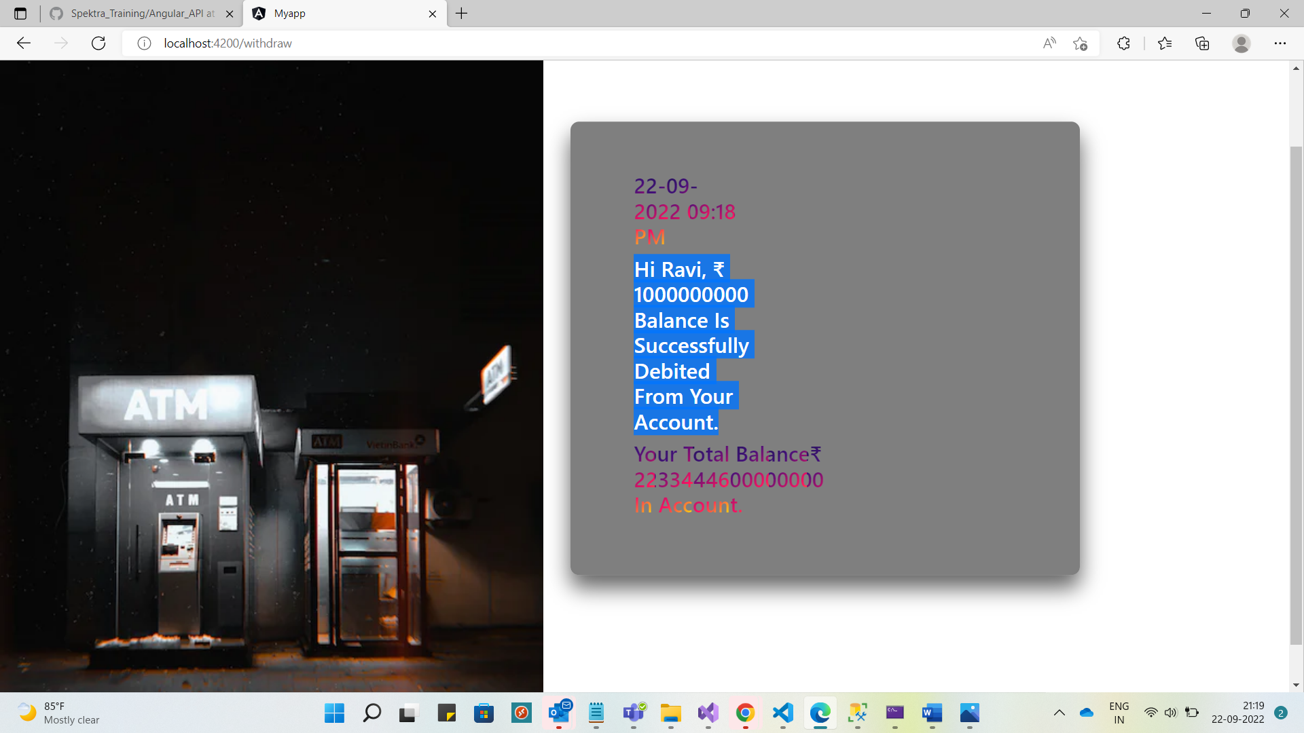

**Deposite :**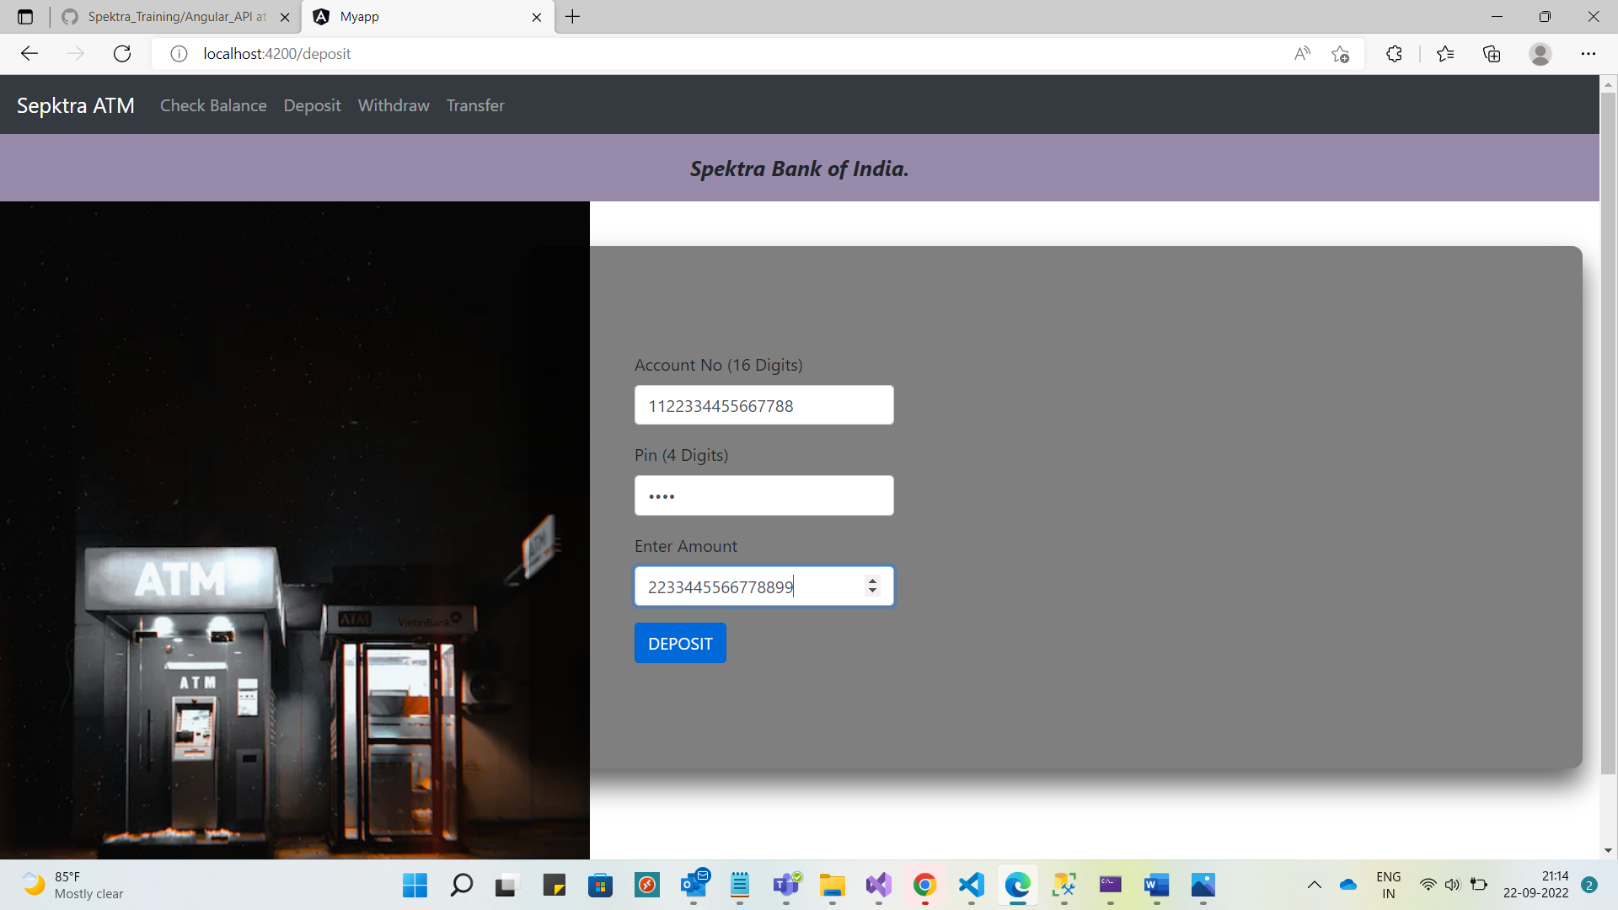

**Transfer Section :**